FORM NO. 12BB
(See rule 26C)
Statement showing particulars of claims by an employee for deduction of tax under section 192
- Name and address of the employee: Lalitha Gudapakkam
- Employee ID: 172806
- Permanent Account Number of the employee: AIMPL3598C
- Financial year: 2022-2023
Details of claims and evidence thereof
Sl. No. | Nature of claim | Amount  (Rs.) | Evidence / particulars
(1) | (2) | (3) | (4)
1. | House Rent Allowance:  (i) Rent paid to the landlord  (ii) Name of the landlord  (iii) Address of the landlord  (iv) Permanent Account Number of the landlord  Note: Permanent Account Number shall be furnished if the aggregate rent paid during the previous year exceeds one lakh rupees
2. | Leave travel concessions or assistance
3. | Deduction of interest on borrowing:  (i) Interest payable/paid to the lender  (ii)Name of the lender  (iii) Address of the lender  (iv) Permanent Account Number of the lender  (a) Financial Institutions(if available)  (b) Employer(if available)  (c) Others
4. | Deduction under Chapter VI-A  (A) Section 80C,80CCC and 80CCD  (i) Section 80C  (a) ……………..  (b) ……………..  (c) ……………..  (d) ……………..  (e) ……………..  (f) ……………..  (g) ……………..  (ii) Section 80CCC  (iii) Section 80CCD  (B) Other sections (e.g. 80E, 80G, 80TTA, etc.) under Chapter VI-A.  (i) section……………….  (ii) section……………….  (iii) section………………  (iv) section……………….  (v) section……………….
 | Verification
 | I, …Lalitha Gudapakkam…, son/daughter of …YADHAVA KRISHNA… do hereby certify that the information given above is complete and correct.
 | Place…Chennai… | 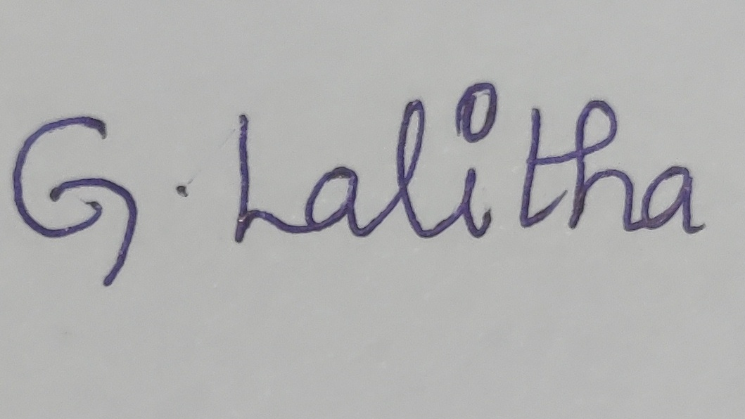
 | Date…02-Dec-2022… | (Signature of the employee)
 | Designation …CONSULTANT II ANALYTICS | Full Name: LALITHA GUDAPAKKAM

